**Randy’s Report**

By Randy Cox, facility Administrator

Did you ever notice how fast times seems to pass the closer you get to Christmas? Here we are with Thanksgiving just a few weeks away and Christmas just over 4 weeks behind that! Like everyone else, I have been busy with my late fall chores: putting the deck furniture away, cleaning out the garden, cleaning and organizing the garage for winter, waxing the cars, etc. Busy, busy, busy.

We have been busy here at the facility as well with fall decorations and functions. One of the highlights included taking a group of residents to the cider press in Pandora on the 11th. I think they enjoyed the country ride as much as the cider press. Of course, we had to celebrate National Bologna day on the 24th with table-side fried Bologna for lunch. The residents enjoyed it, but the whole place smelled like fried Bologna for a couple of hours! We also invited the kids to trick or treat here for Halloween and the residents thoroughly enjoyed seeing the various costumes. We invited staff to dress up as well, which the residents also enjoyed.

November brings Thanksgiving, of course, and we will be treating the residents to a traditional Thanksgiving meal at lunch time including turkey or ham, dressing, yams, green bean casserole and pie. Another big item coming up on the calendar is our December 10th craft show. More on this next month, but please mark your calendar and plan to stop in and finish your Christmas shopping right here at Vancrest of Ada!

I recently received word that our brand new facility bus has arrived in Van Wert! Our Van Wert team is busy getting the title in place and putting it through the required state inspections. We should have it any day, or may already have it by the time you read this. Our Delphos facility has been very generous, loaning us their bus quite often. It will be great, however, having our own and being able to plan resident outings whenever we want!

Have a happy Thanksgiving holiday with your family and friends.

**\*\*\*If you wish to receive your copy of The Ada Articles through e-mail, please e-mail** [**jline@vancrest.com**](mailto:jline@vancrest.com) **and we will get you on the list for the electronic version. Thank You!\*\*\***

**Contact us**

If you have any questions or would like to discuss and of the services we offer, please contact us!

600 W. North St.

Ada, Ohio 45810

Phone: (419)558-1379

Fax: (419)558-1385

Web: Vancrest.com [](http://webserver.vancrest.com/)

****

600 W. North Ave

Ada, Ohio 45810

**The Ada Articles**

**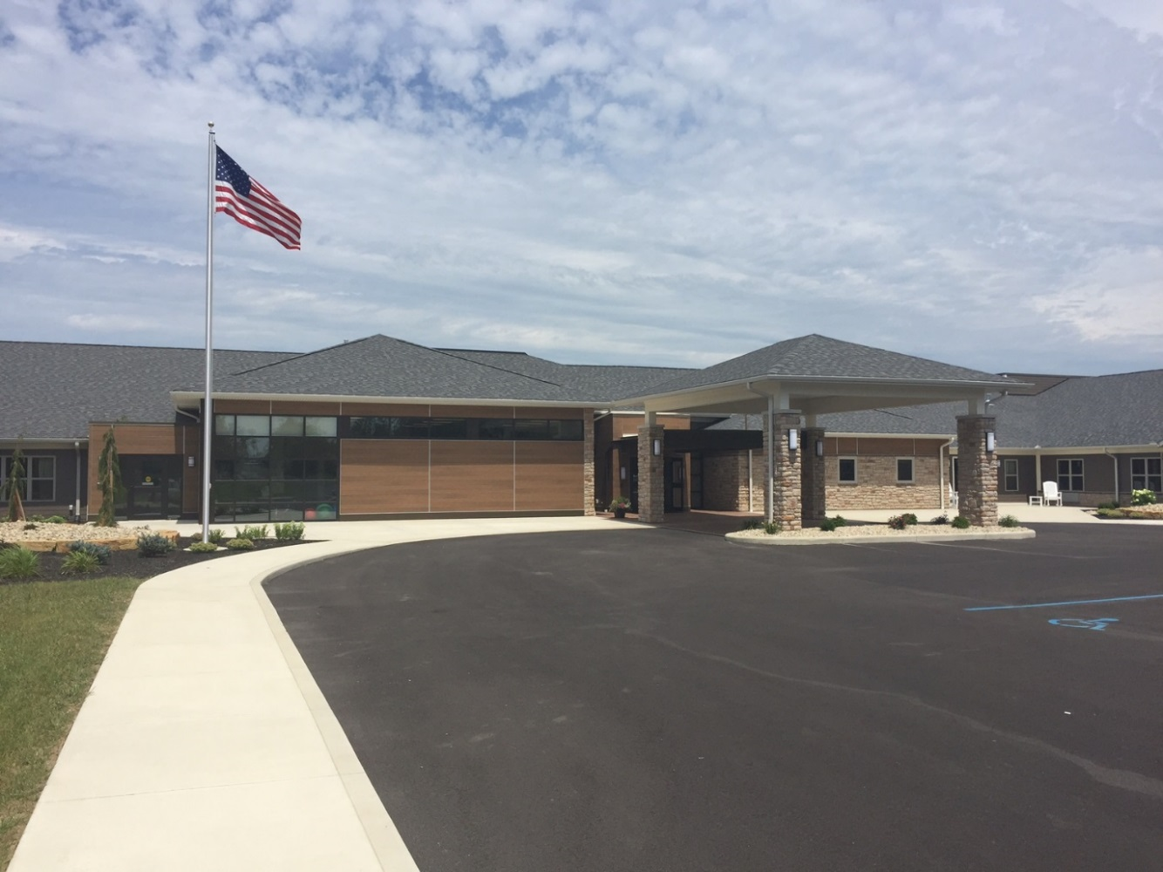**

**Vancrest of Ada**

**November 2016**

**4th Edition**

Monthly News Letter

Happy November! Thanksgiving is only a few short weeks away. All of that family time spent in the kitchen and around the dinner table is such a wonderful thing! Thanksgiving Day football is always a highlight as well! We all hope that this beautiful fall season is one everyone is able to enjoy. We would like to invite everyone to come in and join us for some of the activities here at Vancrest. It is always a good family time and lots of fun!

Not what we say about our Blessings, but how we use them, is the true measure of our Thanksgiving.

-W.T. Purkiser

**Focusing on What We Have Coming Up**

At Vancrest we are dedicated to keeping our residents happy, busy and excited about something we have planned. We strive to have a blissful religious services, delicious snack making, adventurous outings and the best entertainers possible. We have excellent volunteers and activity staff to help you in anything you wish to participate in. If you are looking for something to do with any spare time we would love to have you come in and volunteer. Volunteering is as easy as talking with the residents, painting fingernails, playing games or even coloring. Our bus is here!! Now we are just awaiting all of the final inspections to be completed.

We hope that you find interest in some of our Activity Highlights this Month and come in to share in the fun:

* A fall Scenic Drive on November 22 \* OSU vs. Michigan game apparel on the 25th
* Snacks every Wednesday at 2:00 \* Bingo every Monday at 2pm
* Church every Tuesday evening at 7pm \* Dressing in Thanksgiving Fashion the 23rd

**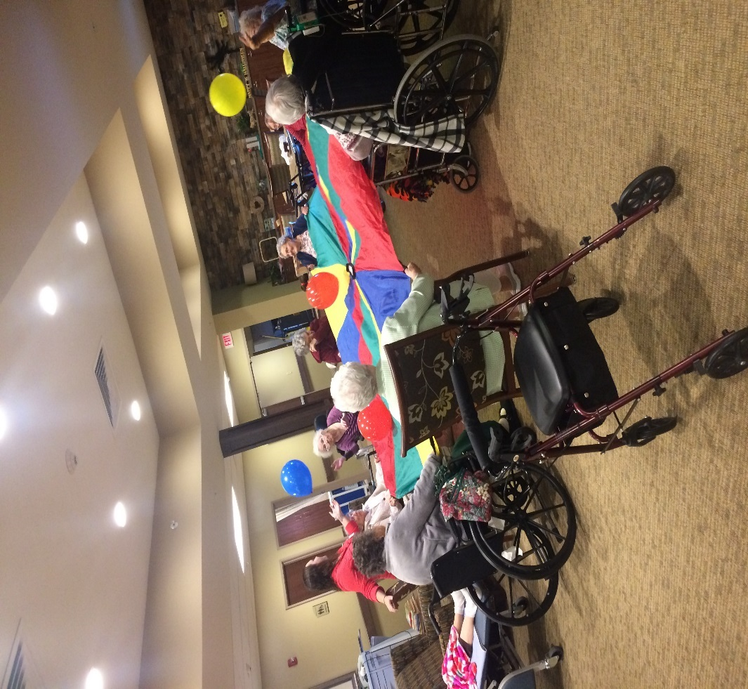**

Playing with our new parachute was big success as a different form of exercise. Making our arms move as well as working as a team to see how high we could throw the balloons.

We also enjoyed bowling in our living room!

**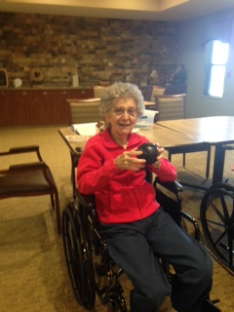 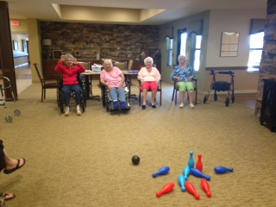**

**Employee Spotlight**

**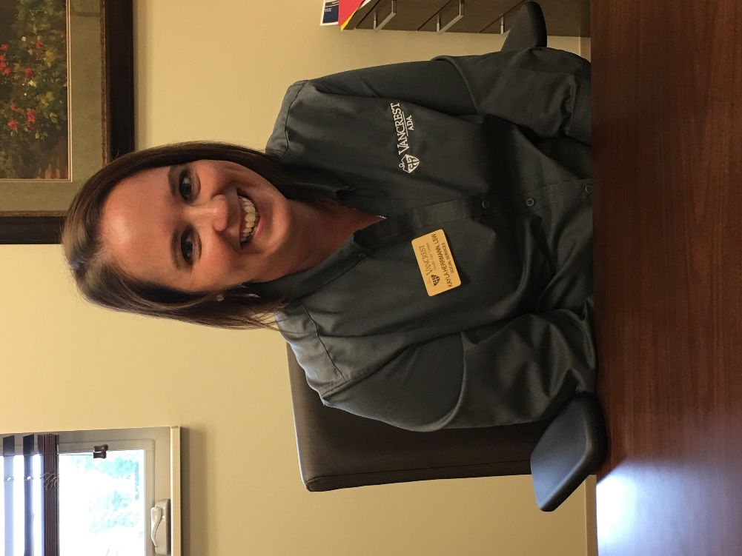**

**Kayla Herrmann** is our Licensed Social Worker here at Vancrest. Kayla also does our marketing, admissions and discharge planning. She attended Bluffton University to attain her Bachelor of Arts Social Work degree. Before Kayla came to us she was a very talented STNA at a local Nursing Home. Although her favorite job was not in the medical field at all, but as a waitress at Bob Evans! When asked about the favorite part of her job Kayla’s answer was getting to meet new people every day. With that being said I hope everyone will take a minute on your way in or out and say Hello to Kayla. She is always so busy it will be nice to have someone stop and just say Hi.

Kayla has recently celebrated a Birthday on October 15th. She spent the day at the Columbus Zoo with her Husband Doug of 11 years and her two wonderful kids Allison (8), and Jonathan (3). Kayla enjoys the fall season the most with Thanksgiving and the football that comes along with it! Her favorite food is Pasta and loves to read in her free time. Her best vacation was a trip to Key West Florida!

Kayla spends many evening and weekend hours at Vancrest working on admissions and meeting families for the loads of paper work that come along with it. She is quite good at this process and can walk anyone through it with ease. Kayla always wears a smile even if it is a stressful day or if she is trying to figure something out for a family. Kayla is always our go to girl because if she doesn’t know an answer she will be the first to figure it out for you. If you don’t know Kayla she is quite the jokester as well. Which may explain her (Shhh…) secret obsession with comic book movies. Something we did not know however is one day she plans to mark Traveling Europe by train off of her Bucket List.

**Resident Spotlight**

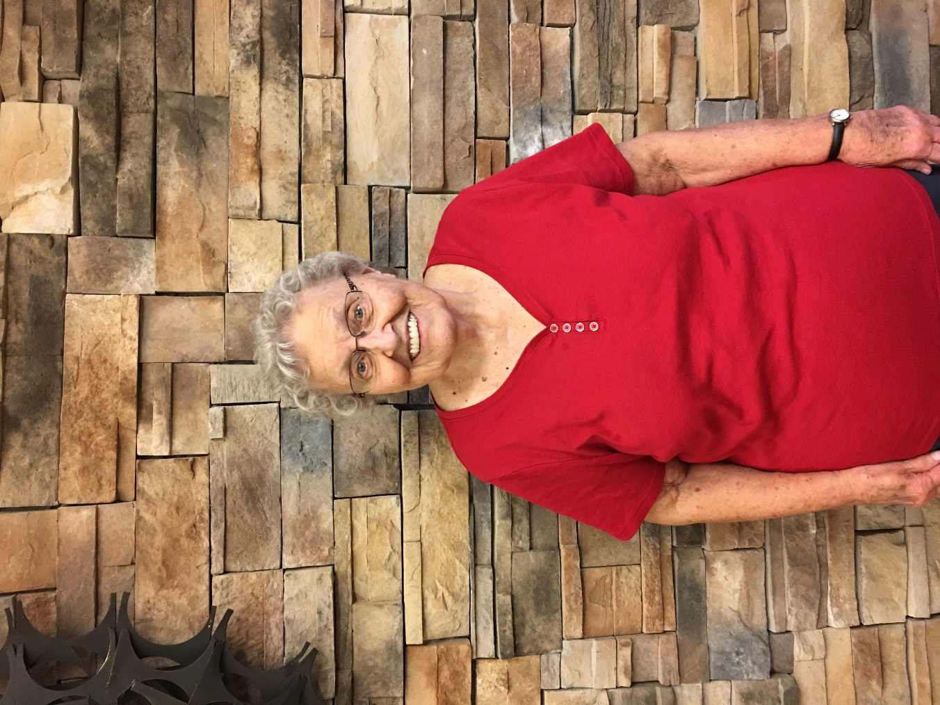

We would like to introduce Miriam Marshall**.** She was a school teacher for 33 years. All of her years were devoted to teaching 1st grade in Arlington and USV. What a wonderful job for such a wonderful lady. Miriam graduated from Dunkirk High school in 1949 with a class size of 24. Miriam has a birthday coming up on November 19th, so be sure to send good wishes her way.

Miriam was Married to her husband Jack for 62 years and they had 4 children together. They had a set of twin boys as well as another son and daughter. Something not many people know is that she had all 3 boys in one year! Her oldest son was born in January and then her twins were born in December. Miriam believes that her family is the best part of her life now as they are all so very important to her.

Miriam said that Spring is her favorite season but her heart always goes to Thanksgiving when it comes to the holidays. She enjoys watching volleyball and is quite the player when it comes to our games of Balloon Volleyball here at Vancrest! Hawaii or Disneyland were the best memories of vacation for Miriam. When it comes to food Ice Cream is what she really enjoys! Miriam says she never had a Bucket list as her and Jack did everything that they wanted to in life, which is amazing! If there was one thing Miriam could do different being diabetic would be something she would change. Other than that when asked if there was anything she would change she stated “No way, I was blessed with a good family, and good life.” We are so lucky to have Miriam here in our Facility and I hope everyone gets a chance to get to know her as we have!

**The Mission Statement of Vancrest of Ada is to Provide CARE:**

                      C             Customer Focused- Resident, Family &

Community

                                A             Attitude- Always Display a Positive Attitude

                                R             Responsibility- Each Person Takes

Responsibility for Results

                                E            Empathy- Display Empathy to Customers In All

Situations

[](http://www.bing.com/images/search?q=clipart+nursing+home&id=621ABCC90AA72575AA3BFCB373D1031961E2D777&FORM=IQFRBA)

**We Will Achieve the Mission Through Key Objectives:**

1. Care- Individualized care that is delivered timely, proactively, professionally, and with a caring attitude.
2. Nutritional Services- The dining experience and meals will be served at the right

temperature, time, place and nutritional value.  We will offer a choice at each meal.

1. Facilities- Vancrest of Ada is an odor free, secure, accessible, and comfortable

facility.  This is accomplished by timely attention to investment in physical structure and pride in accommodations.

1. Activities- Meaningful and varied activities will be offered at a variety of times that will

stimulate the senses and be fun.

1. Staff- Employees at Vancrest of Ada strive for total customer satisfaction in everything

we do by accomplishing results in a proactive, professional approach.

|  |  |
| --- | --- |
| November |  |
|  | 2016 |
| Activities Calendar Long Term Care | Activities are subject to change. Changes will be posted on Large wall calendar. |

|  |  |  |  |  |  |  |
| --- | --- | --- | --- | --- | --- | --- |
| Sunday | Monday | Tuesday | Wednesday | Thursday | Friday | Saturday |
|  |  | 1 | 2 | 3 | 4 | 5 |
|  |  | 10:00am Ring Toss  2:00pm Wheel of Fortune  7:00pm Church | 10:00am Exercise  1:30pm Deviled Eggs  2:00pm Ada Library Book Drop | 10:00am Parachute  2:00pm Bible Study with Ron Shumaker  3:15pm Balloon Volleyball | 10:00am Arts and Crafts  2:00pm Family Feud  3:00pm Ice Cream Social | 10:00am Activity Area  2:00pm Puzzles |
| 6 | 7 | 8 | 9 | 10 | Veteran’s Day 11 | 12 |
| 9:00am Joel Osteen Ch.42  2:00pm Word Searches  6:00pm Frozen Treats | 10:00am Exercise  2:00pm Bingo  3:00pm Nail Spa | 10:00am Exercise  2:00pm Family Feud  7:00pm Church | 10:00am Parachute  2:00pm Root beer Floats  2:30pm Movie Day (give me requests) | 10:00am Parachute  2:00pm Bible Study with Ron Shumaker  3:15pm Balloon Volleyball | 10:00am Reminiscing  2:00pm Bingo  3:00pm Exercise | 1:00pm-3:00pm Activities with Amber  4:00pm Coloring Pages |
| 13 | 14 | 15 | 16 | 17 | 18 | 19 |
| 9:00am Joel Osteen Ch.42  2:00pm Word Searches  6:00pm Frozen Treats | 10:00am Exercise  2:00pm Bingo  3:00pm Nail Spa | 10:00am Facts and Trivia  2:00pm Ring Toss  7:00pm Church | 10:00am Exercise  2:00pm Sweet Surprise  3:00pm Resident Council-LTC | 10:00am Parachute  2:00pm Bible Study with Ron Shumaker  3:15pm Balloon Volleyball | 10:00am Ring Toss  1:30pm Scenic Drive  3:30pm Bowling | 2:00pm Puzzles  4:00pm Word Searches |
| 20 | 21 | Go for a Ride Day 22 | Eat a Cranberry Day 23 | Thanksgiving Day!! 24 | OSU vs. Michigan Attire 25 | 26 |
| 9:00am Joel Osteen Ch.42  2:00pm Word Searches  6:00pm Frozen Treats | 10:00am Exercise  2:00pm Bingo  3:00pm Nail Spa | 9:00am Bus Ride  11:30am Pizza Hut-Kenton  3:30pm Balloon Volleyball  7:00pm Church | 10:00am Facts and Trivia  2:00pm Cranberry Snack  3:00pm Ring Toss | 10:00am Turkey Decorating  Thanksgiving Lunch  2:00pm Puzzles | 10:00am Corn Hole  2:00pm Football game snacks  3:00pm Resident Council-AL | 1:00pm-3:00pm Activities with Amber  4:00pm Coloring Pages |
| 27 | 28 | 29 | 30 |  |  |  |
| 9:00am Joel Osteen Ch.42  2:00pm Word Searches  6:00pm Frozen Treats | 10:00am Exercise  2:00pm Bingo  3:00pm Nail Spa | 10:00am Exercise  2:00pm Movie Day (give me requests)  7:00pm Church | 10:00pm Facts and Trivia  2:00pm Birthday Party  3:00pm Parachute | C:\Users\jline\AppData\Local\Microsoft\Windows\Temporary Internet Files\Content.Outlook\0NGMIQ52\IMG_3469.JPG | C:\Users\jline\AppData\Local\Microsoft\Windows\Temporary Internet Files\Content.Outlook\0NGMIQ52\IMG_3450.JPG | C:\Users\jline\AppData\Local\Microsoft\Windows\Temporary Internet Files\Content.Outlook\0NGMIQ52\IMG_3467.JPG |
|  |  |  |  |  |  |  |
| **We want to thank everyone who came out and supported us in our First *Trick or Treat*!!** | C:\Users\jline\AppData\Local\Microsoft\Windows\Temporary Internet Files\Content.Outlook\0NGMIQ52\IMG_3463.JPG | C:\Users\jline\AppData\Local\Microsoft\Windows\Temporary Internet Files\Content.Outlook\0NGMIQ52\IMG_3462.JPG | C:\Users\jline\AppData\Local\Microsoft\Windows\Temporary Internet Files\Content.Outlook\0NGMIQ52\IMG_3461.JPG | C:\Users\jline\AppData\Local\Microsoft\Windows\Temporary Internet Files\Content.Outlook\0NGMIQ52\IMG_3460.JPG | C:\Users\jline\AppData\Local\Microsoft\Windows\Temporary Internet Files\Content.Outlook\0NGMIQ52\IMG_3457.JPG | Activities are subject to change. We encourage Family and Friends to come in and join us in all of the fun!  Outings will be weather permitting. |

|  |  |
| --- | --- |
| November |  |
|  | 2016 |
| Activities Calendar Assisted Living | Activities are subject to change. Changes will be posted on Large wall calendar. |

|  |  |  |  |  |  |  |
| --- | --- | --- | --- | --- | --- | --- |
| Sunday | Monday | Tuesday | Wednesday | Thursday | Friday | Saturday |
|  |  | 1 | 2 | 3 | 4 | 5 |
|  |  | 10:00am Ring Toss  2:00pm Wheel of Fortune  7:00pm Church | 10:00am Exercise  1:30pm Deviled Eggs  2:00pm Ada Library Book Drop | 10:00am Parachute  2:00pm Bible Study with Ron Shumaker  3:15pm Balloon Volleyball | 10:00am Arts and Crafts  2:00pm Family Feud  3:00pm Ice Cream Social | 10:00am Activity Area  2:00pm Puzzles |
| 6 | 7 | 8 | 9 | 10 | Veteran’s Day 11 | 12 |
| 9:00am Joel Osteen Ch.42  2:00pm Word Searches  6:00pm Frozen Treats | 10:00am Exercise  2:00pm Bingo  3:00pm Nail Spa | 10:00am Exercise  2:30pm Family Feud  7:00pm Church | 10:00am Parachute  2:00pm Root beer Floats  2:30pm Movie Day (give me requests) | 10:00am Parachute  2:00pm Bible Study with Ron Shumaker  3:15pm Balloon Volleyball | 10:00am Reminiscing  2:00pm Bingo  3:00pm Exercise | 1:00pm-3:00pm Activities with Amber  4:00pm Coloring Pages |
| 13 | 14 | 15 | 16 | 17 | 18 | 19 |
| 9:00am Joel Osteen Ch.42  2:00pm Word Searches  6:00pm Frozen Treats | 10:00am Exercise  2:00pm Bingo  3:00pm Nail Spa | 10:30am Facts and Trivia  2:00pm Ring Toss  7:00pm Church | 10:00am Exercise  2:00pm Sweet Surprise  3:00pm Resident Council-LTC | 10:00am Parachute  2:00pm Bible Study with Ron Shumaker  3:15pm Balloon Volleyball | 10:00am Ring Toss  1:30pm Scenic Drive  3:30pm Bowling | 2:00pm Puzzles  4:00pm Word Searches |
| 20 | 21 | Go for a Ride Day 22 | Eat a Cranberry Day 23 | Thanksgiving Day!! 24 | OSU vs. Michigan Attire 25 | 26 |
| 9:00am Joel Osteen Ch.42  2:00pm Word Searches  6:00pm Frozen Treats | 10:00am Exercise  2:00pm Bingo  3:00pm Nail Spa | 9:00am Bus Ride  11:30am Pizza Hut-Kenton  3:30pm Balloon Volleyball  7:00pm Church | 10:30am Facts and Trivia  2:00pm Cranberry Snack  3:00pm Ring Toss | 10:00am Turkey Decorating  Thanksgiving Lunch  2:00pm Puzzles | 10:00am Corn Hole  2:00pm Football game snacks  3:00pm Resident Council-AL | 1:00pm-3:00pm Activities with Amber  4:00pm Coloring Pages |
| 27 | 28 | 29 | 30 |  |  |  |
| 9:00am Joel Osteen Ch.42  2:00pm Word Searches  6:00pm Frozen Treats | 10:00am Exercise  2:00pm Bingo  3:00pm Nail Spa | 10:00am Exercise  2:00pm Movie Day (give me requests)  7:00pm Church | 10:30pm Facts and Trivia  2:00pm Birthday Party  3:00pm Parachute | C:\Users\jline\AppData\Local\Microsoft\Windows\Temporary Internet Files\Content.Outlook\0NGMIQ52\IMG_3469.JPG | C:\Users\jline\AppData\Local\Microsoft\Windows\Temporary Internet Files\Content.Outlook\0NGMIQ52\IMG_3450.JPG | C:\Users\jline\AppData\Local\Microsoft\Windows\Temporary Internet Files\Content.Outlook\0NGMIQ52\IMG_3467.JPG |
|  |  |  |  |  |  |  |
| **We want to thank everyone who came out and supported us in our First *Trick or Treat*!!** | C:\Users\jline\AppData\Local\Microsoft\Windows\Temporary Internet Files\Content.Outlook\0NGMIQ52\IMG_3463.JPG | C:\Users\jline\AppData\Local\Microsoft\Windows\Temporary Internet Files\Content.Outlook\0NGMIQ52\IMG_3462.JPG | C:\Users\jline\AppData\Local\Microsoft\Windows\Temporary Internet Files\Content.Outlook\0NGMIQ52\IMG_3461.JPG | C:\Users\jline\AppData\Local\Microsoft\Windows\Temporary Internet Files\Content.Outlook\0NGMIQ52\IMG_3460.JPG | C:\Users\jline\AppData\Local\Microsoft\Windows\Temporary Internet Files\Content.Outlook\0NGMIQ52\IMG_3457.JPG | Activities are subject to change. We encourage Family and Friends to come in and join us in all of the fun!  Outings will be weather permitting. |