[](http://www.bing.com/images/search?q=trick+or+treat+clip+art&view=detailv2&&id=9D67F18C5F5C99434A0F495398AF2E679CFCA909&selectedIndex=57&ccid=XkfiweuM&simid=608024081593797405&thid=OIP.M5e47e2c1eb8cb961067e460d729a1409o0)[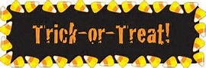](http://www.bing.com/images/search?q=trick+or+treat+clip+art&view=detailv2&&id=1B24EC1E7FCE5711EBCE0AD8AF400A544E9CB5EE&selectedIndex=77&ccid=fFEHSXuc&simid=608038083188752745&thid=OIP.M7c5107497b9c70585447e66c091bfa75o0)[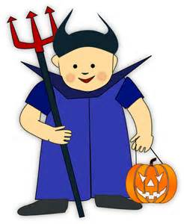](http://www.bing.com/images/search?q=trick+or+treat+clip+art&view=detailv2&&id=7F05FA2E37E41497ADA2F5AD8650B8ED519D1686&selectedIndex=74&ccid=8AzPauGV&simid=608011866704972769&thid=OIP.Mf00ccf6ae195af4250b7278fa8e20d42o0)

October 27th[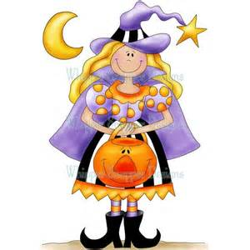](http://www.bing.com/images/search?q=trick+or+treat+clip+art&view=detailv2&&id=28E86F861314F1D578E9BC4130AE26D848517983&selectedIndex=50&ccid=neTy7nml&simid=607998058390555640&thid=OIP.M9de4f2ee79a5c45182bb05fc039e12a1o0)

[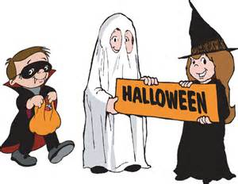](http://www.bing.com/images/search?q=trick+or+treat+clip+art&view=detailv2&&id=E3657955E6F9AC408670E41292BA7BF2640C380C&selectedIndex=61&ccid=l3TWNeRs&simid=608046943701763342&thid=OIP.M9774d635e46cab36002c7bac6997202do0) 5:30pm-7:30pm

*** We hope you add us to your Route! ***

Our residents are very excited to enjoy the costumes and give the kids loads of candy!

[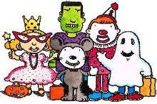](http://www.bing.com/images/search?q=trick+or+treat+clip+art&view=detailv2&&id=9D5E1151AA871BF39605119D1CAB7B57331DF912&selectedIndex=48&ccid=3lfEqkcc&simid=608052183566126054&thid=OIP.Mde57c4aa471c0cf82678a4f31ca36dabo0)

** Come and bring your little ghosts and goblins and enjoy a Trick or Treat out of the weather! **

****600 West North Ave.