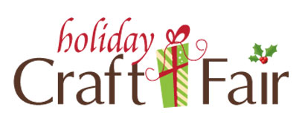

**Open to the Community**

Saturday, December 10,2016

9:00am-4:00pm

$30 Providing your own table

$35 Using one of our tables

$5 if you need electric at your table

Cutoff date is November 21st

Vancrest of Ada

600 West North Ave.

Ada, Ohio 45810

If you are interested in being a Vendor please contact Jennifer Line, Activities Director to make your reservation today. Also please let us know what you will be bringing so we can plan accordingly. (419)558-1379

