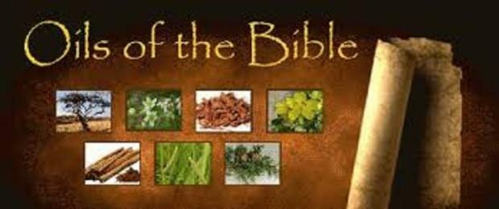

**Healing Oils of the Bible Class Monday Sept. 29, 6:30 pm**

**@ Restore 210 N. Main Ada, Oh. 45810**

**RSVP by Sept. 25th 419-558-1015**

**Class is Free, but there is charge for the Zyto Compass Scan.**

**There will be two stations set up for the zyto compass scan during this class if you would like to have a zyto scan done as well. They will be charging $10.00 for the scan, but it is well worth it to "see" what oils your body needs.**

